**IST 722 – Data Warehousing**

**Jagannathan Govindan**

**NetID: jgovinda**

**Date: 7/20/2019**

**Assignment 1**

|  |  |  |  |  |
| --- | --- | --- | --- | --- |
| Table | Type | Row Count | Business Key | One Row is |
| Employees | Master Table | 9 | None(PK used) | An employee |
| EmployeeTerritories | Business Process | 49 | None(PK used) | An employee assigned to a Territory |
| Customers | Master Table | 91 | Customer ID | A customer |
| Suppliers | Master Table | 29 | None(PK used) | A supplier |
| Products | Master Table | 77 | None(PK used) | A product with its supplier id and category id with current status |
| Shipment(of Orders) | Business process | 830 | None(PK used) | An order with its shipment details |
| Details(of an Order) | Business process | 830 | CustomerID  OrderID  ProductID | An order with customer and sales person details |

1. List the customer contact names and titles sorted by company name.

**Screenshot of Query 1:**

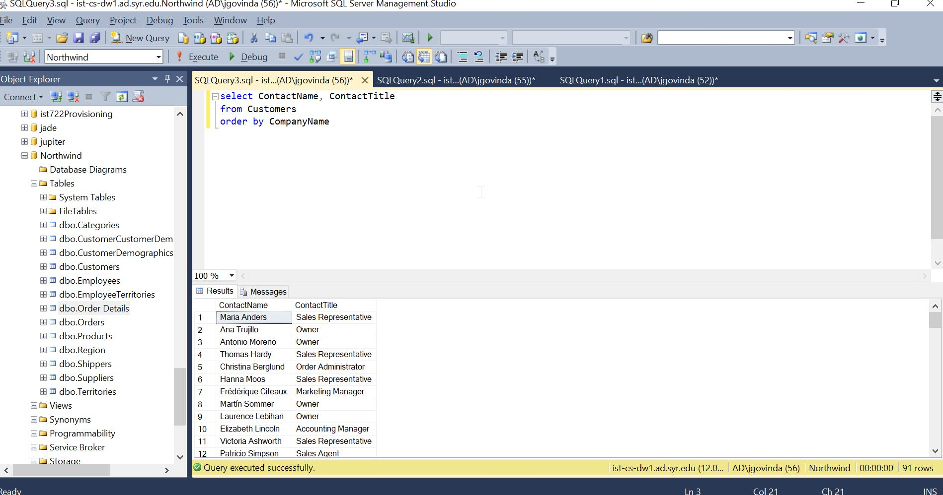

1. Factoring in discounts, what is total amount of product sold?

**Screenshot from Query 2:**

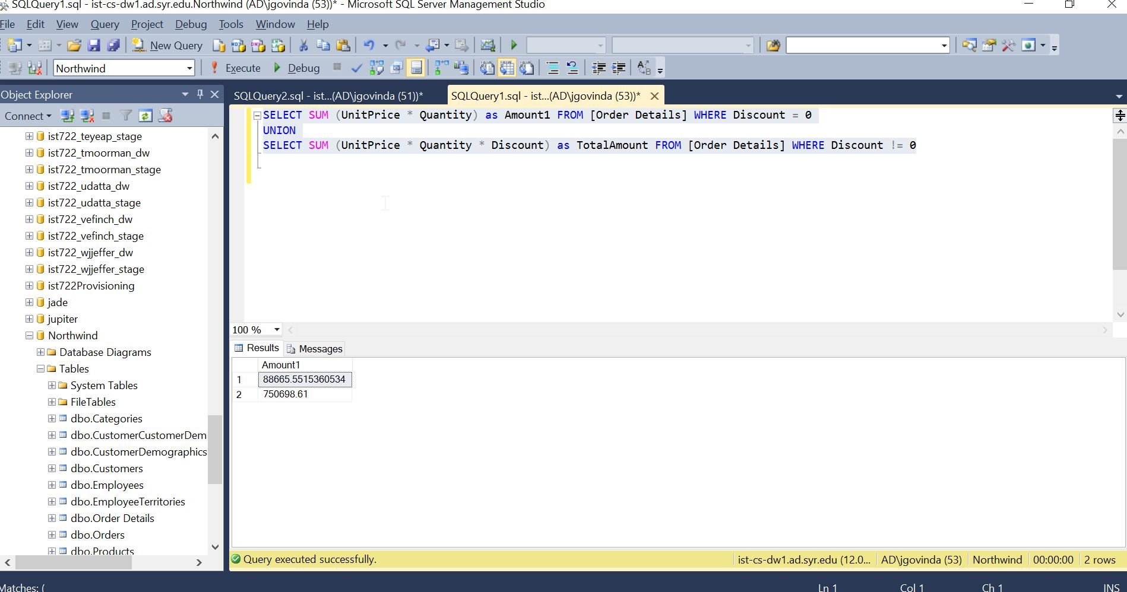

1. Provide a list of product category names with counts of products in each category.

**Screenshot for Query 3:**

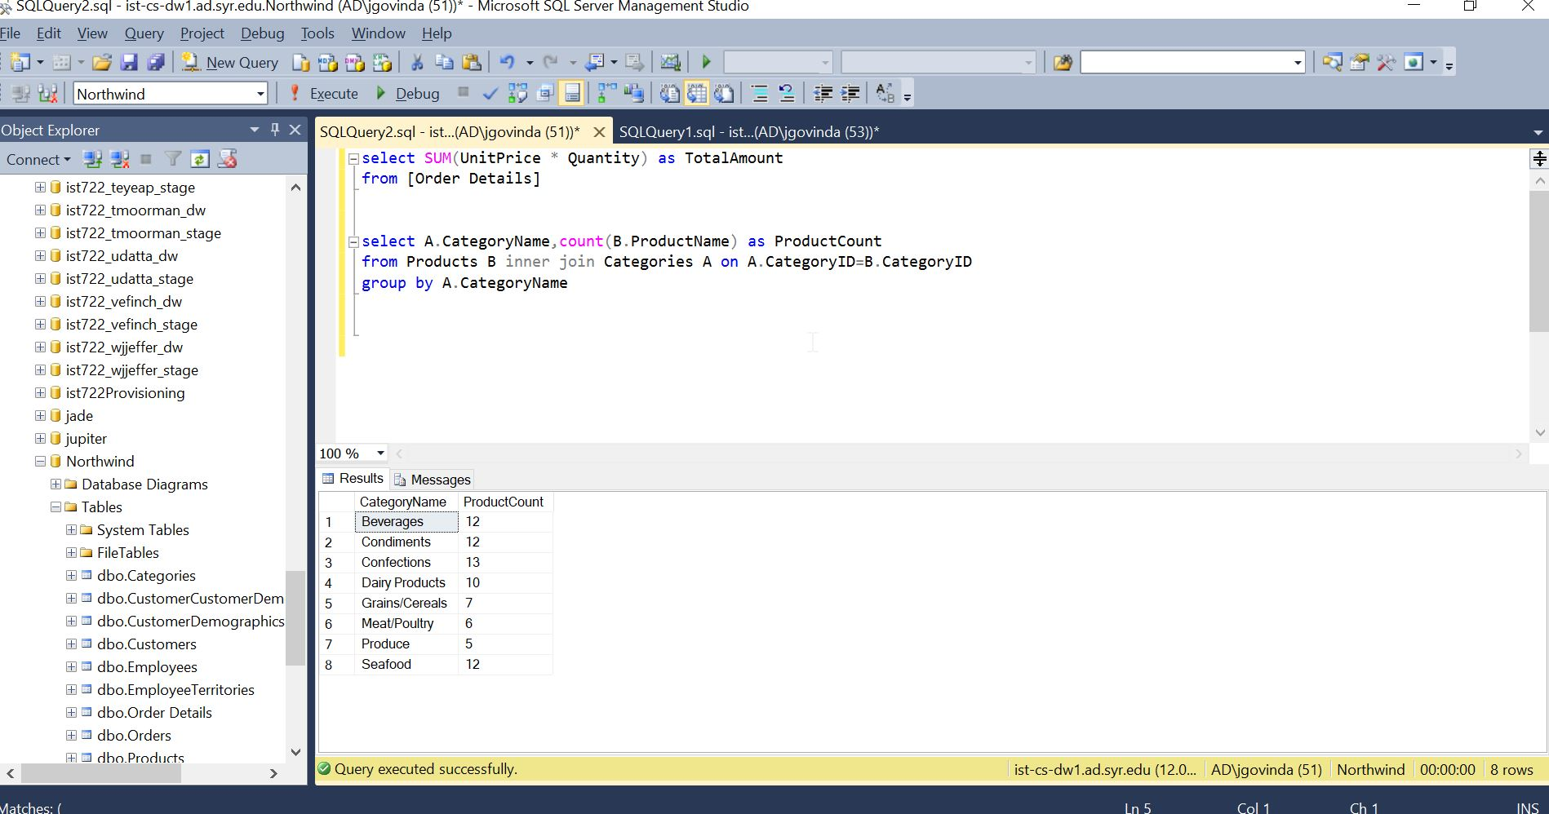

1. Select a specific customer, and display that customer’s orders with total amount of product sold for each order.

**Screenshot for Query 4:** 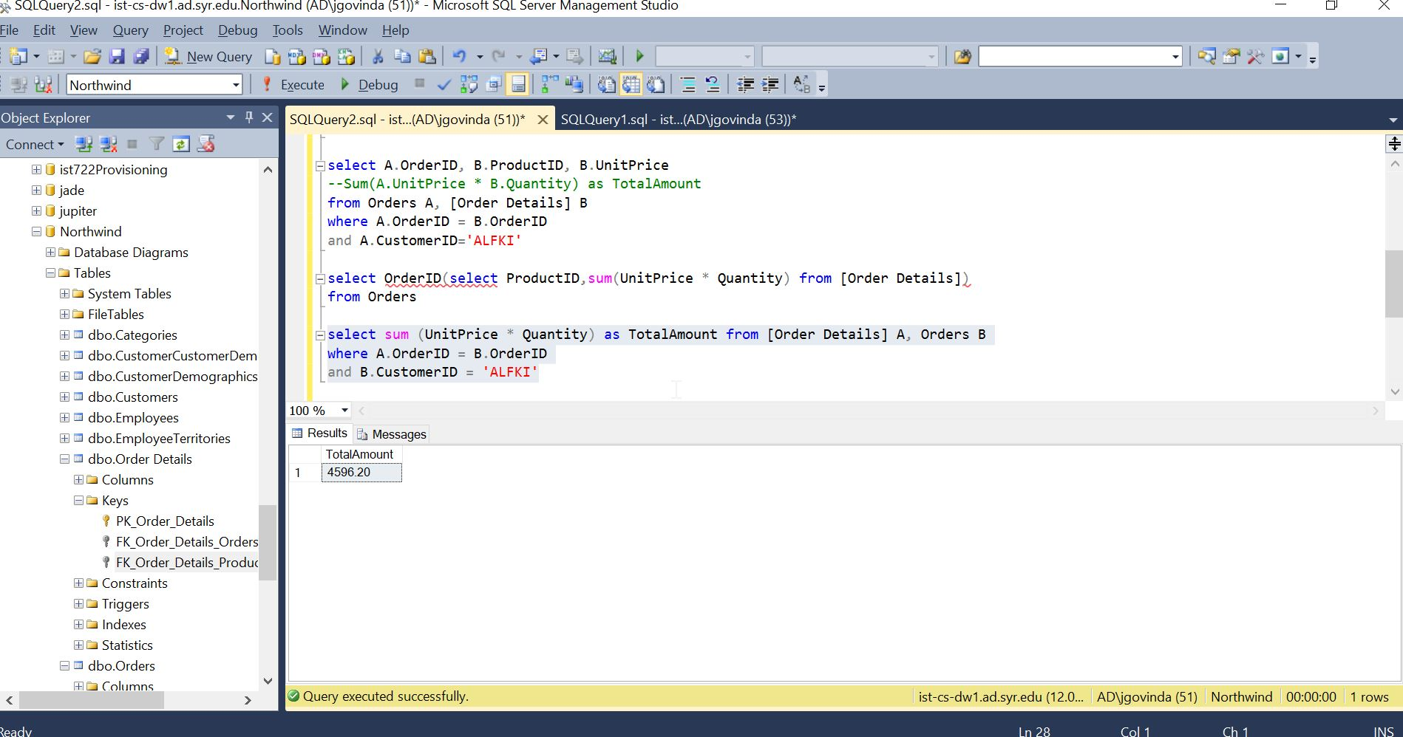

1. Select a specific employee and each order, how it was shipped (shipvia), the company who shipped it, and the total number of days elapsed from order date to shipped date.

**Screenshot for Query 5:**

